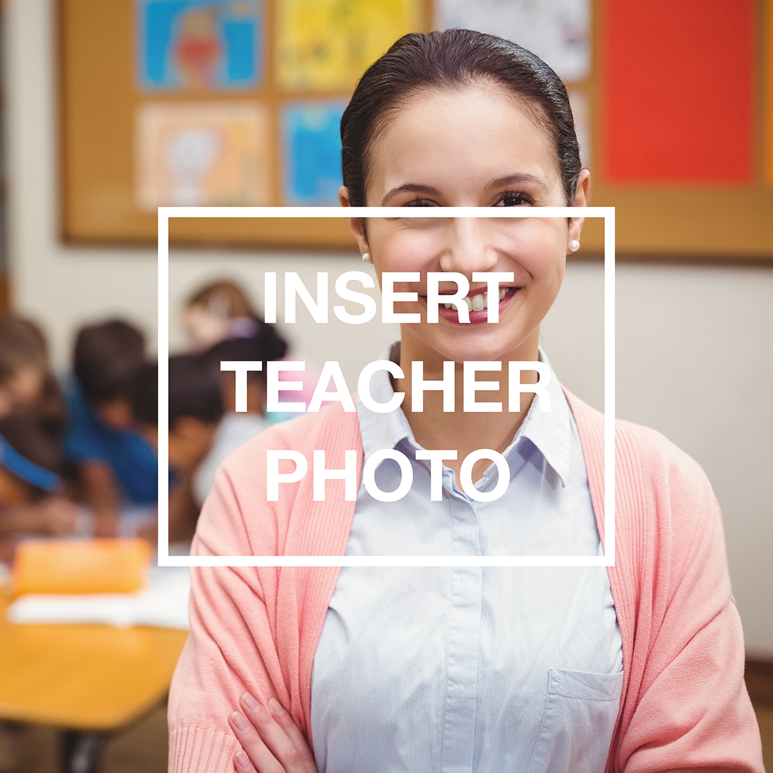

Dear Parent,

My name is **<*insert name*>** and I will be teaching your child in SRE this year.

Our SRE class is a collaborative effort and the teachers are from a variety of local churches. I am a member of **<*insert name of church*>** and if you would ever like to visit our church you are more than welcome. Our website is **<*insert web address*>**

I have been teaching SRE in primary schools for <*insert*> years and I love it.

When I am not teaching, I enjoy ***<insert details>***.

I will be using a curriculum called ***<insert name of curriculum>*** to teach the children about the Bible. We will sing songs, hear stories from the Bible, learn memory verses, complete activity sheets and much more in each lesson.

If you would like to know more about what is taught in SRE, please visit **whysre.com.au**

I am very much looking forward to getting to know your child through our SRE lesson each week.

If you have any questions, then please don’t hesitate to contact me through the office.

Kind regards,

**<*insert name*>**